HOW TO REGISTER FOR CLASSES

Before you start to register, please make sure
- Your emergency contact information is updated
- You have no holds on your account
- You are greenlighted (If you are not, you will see an error that says “You have not been greenlighted yet”
- If you are looking to register for COUN 6398 – Internship & COUN 6399 – Practicum, Please submit the Practicum/Internship application from the handbook
Link to handbook: https://www.wtamu.edu/_files/docs/WT_Student_Handbook_COUNSED_Program_Fall_2021.pdf
- PLEASE FOLLOW ALL 9 STEPS to register
STEP 1: Log into Buff Portal on www.wtamu.edu

STEP 2: Once you log in, select Buff Advisor link has shown.

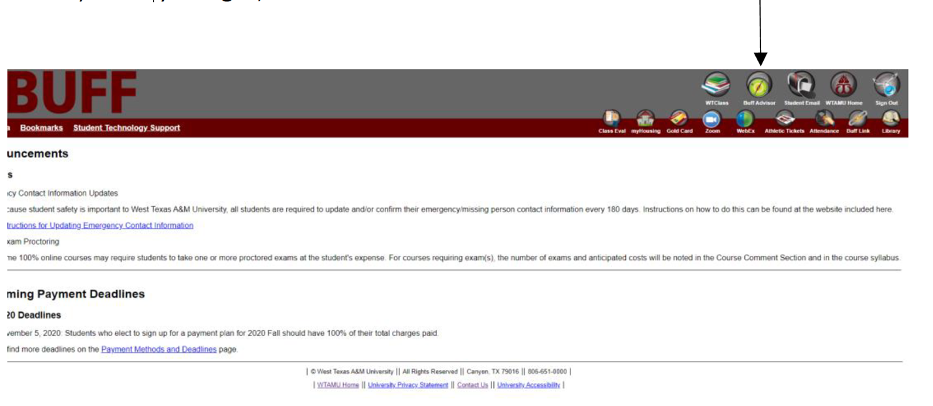

STEP 3: Click on “Search for Classes”

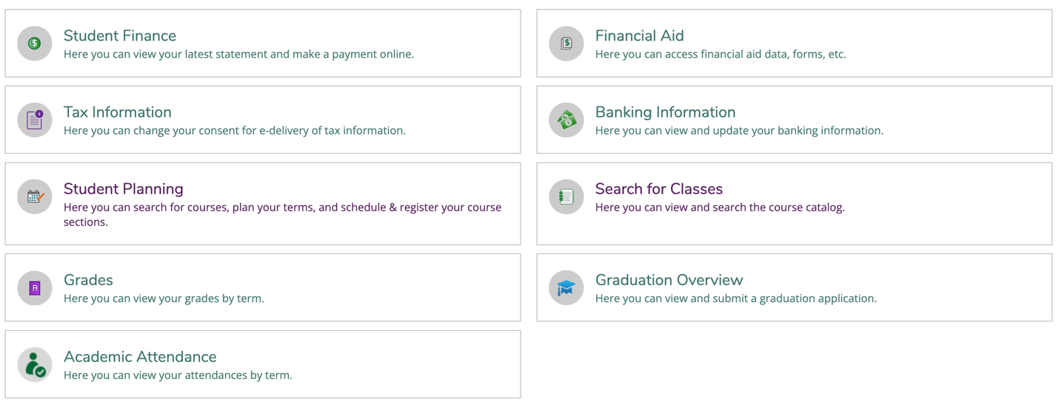

STEP 4: You will complete an “Advanced Search” to find the classes you would like to register for
You can find the Course numbers in your program rotation provided to you at the time of admission. OR if you would like see all courses that are being offered in one semester, you can leave the course number and sections empty.
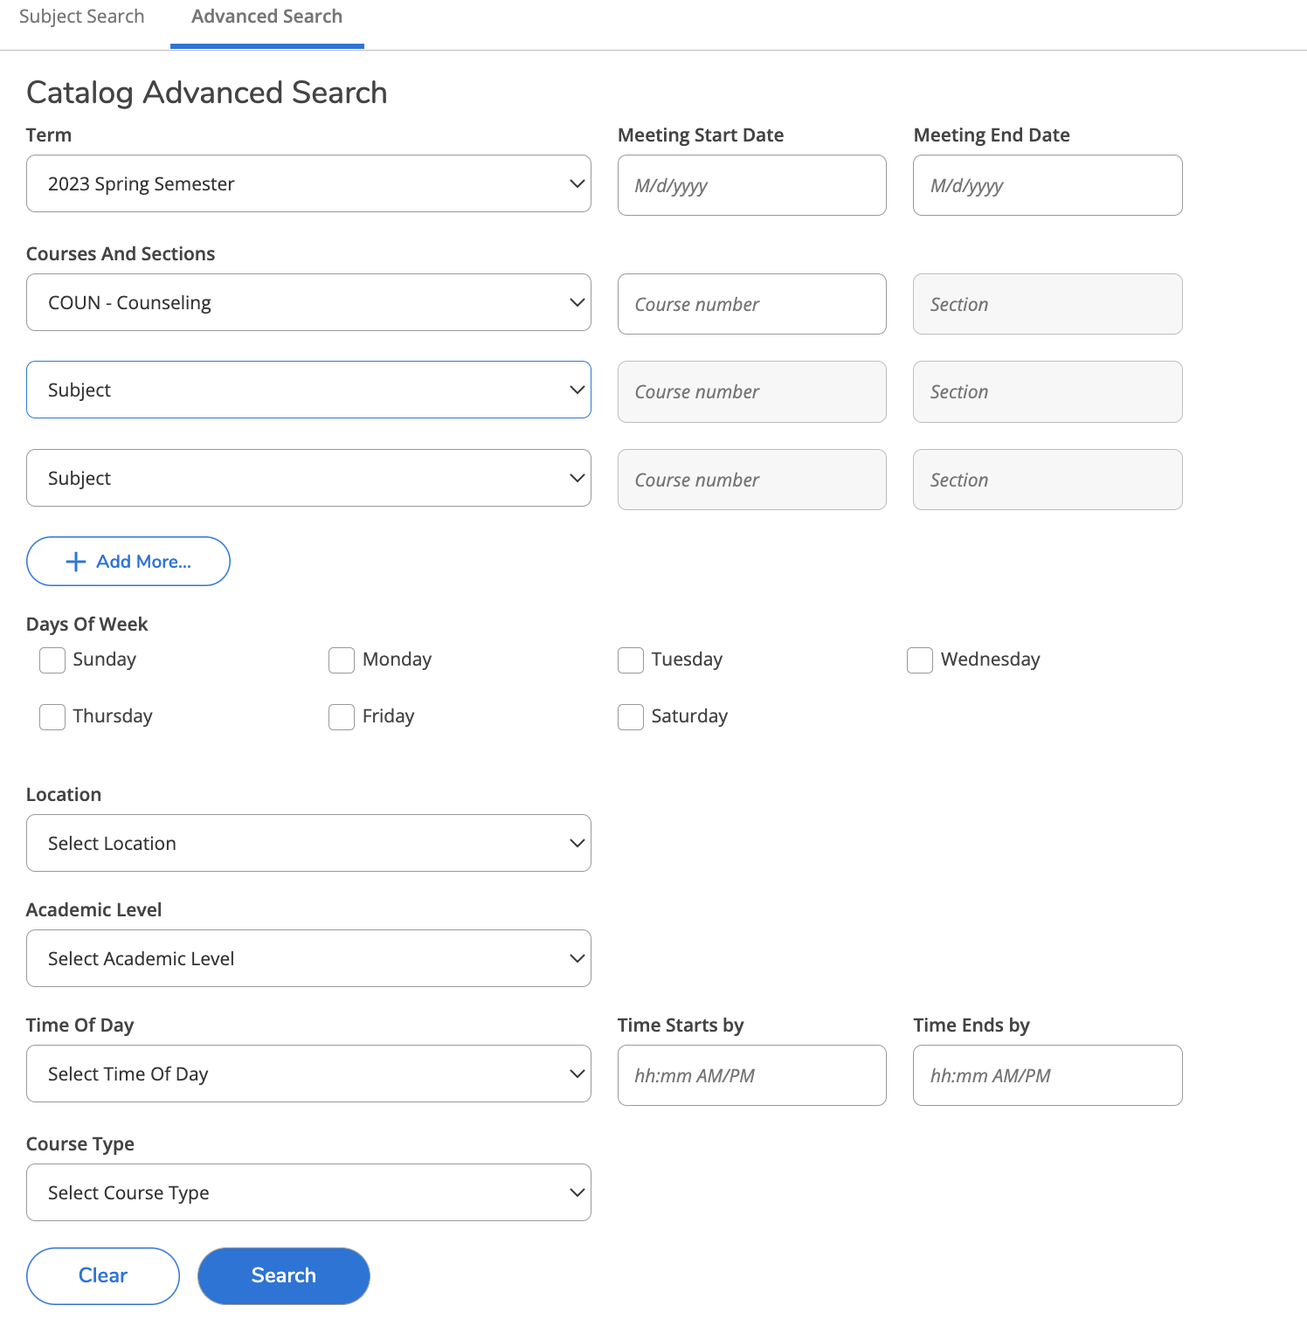
You can leave this empty
y
You will pick “WEB-BASED”
y
You will pick “Graduate”
y
You can leave this empty
y
You can leave this empty
y
Click on Search
y

STEP 5: You will be required to pick the section for the course you would like to register for. Some courses can have two section which is the 70 & 71. A course with section will look like “COUN 6308*70“You can register for either section. The course information for each section is the same.

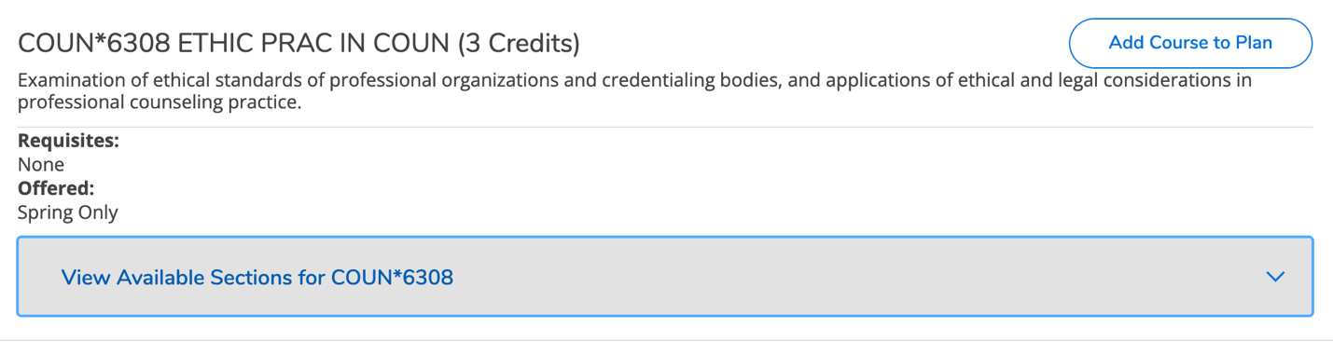
Click on this to expand this section

STEP 6: You will be required to add section to your schedule.
Please remember, not all courses will have two sections. This will only be the case for certain courses.
DO NOT STOP HERE. YOU ARE NOT REGISTRED!
If one section if full, please add the second one to your schedule. BOTH SECTIONS HAVE THE SAME COURE INFORMATION!!
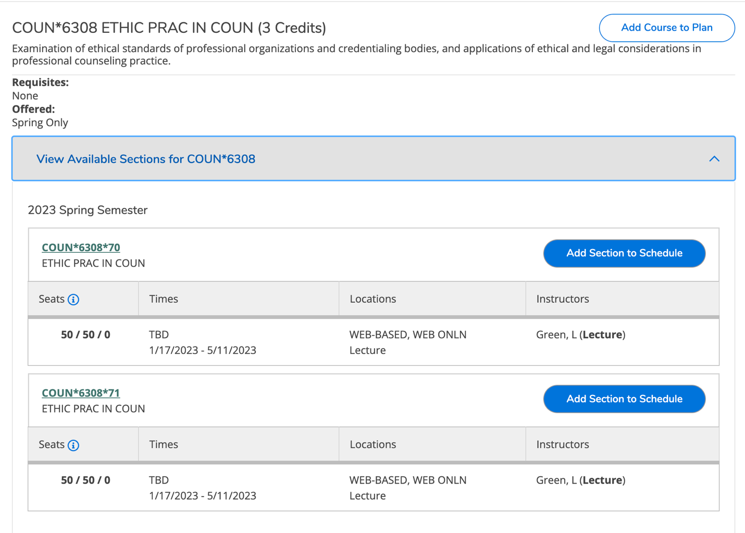
You will add a section to your timeline

STEP 7: In Buff Advisor, on the left hand menu select Student Planning

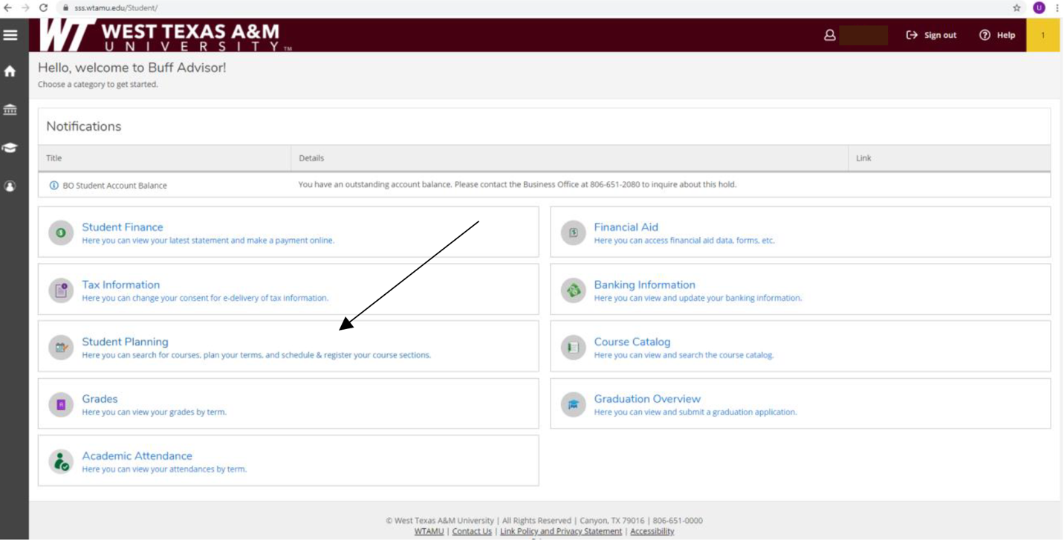

STEP 8: Then select; “Go to plan and Schedule”.

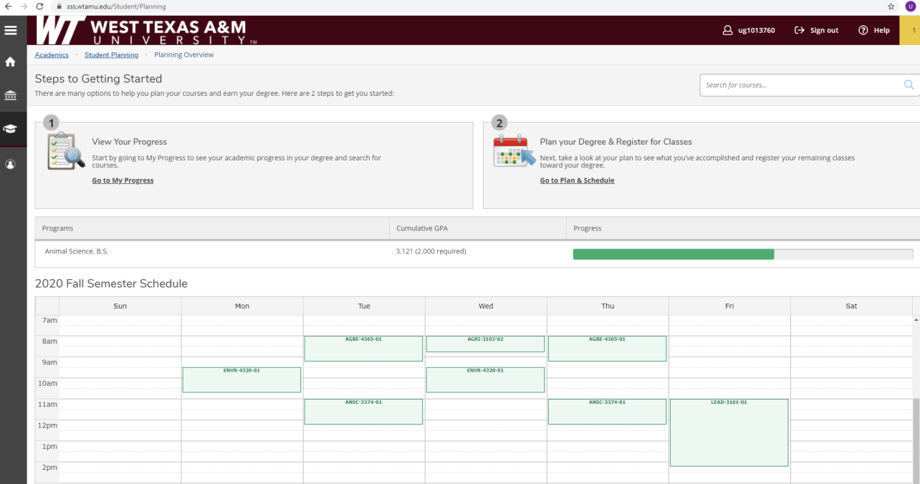

STEP 9:
Use the arrows next to the semester to get to the current semester. You will need to make sure sections are selected for all courses planned (STEPS 1 to 6). When your registration block opens, the “Register Now” button will activate and turn blue. It is important to use the “Register Now” button instead of registering class by class. After you select “Register Now” all planned courses will be green and you will be registered for the semester!

